 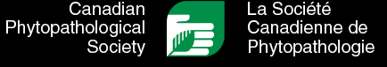 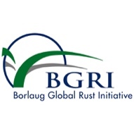

**17th International Cereal Rusts & Powdery Mildews Conference 2025**

**Annual Meeting of the Canadian Phytopathological Society 2025**

**BGRI Technical Workshop 2025**

**Abstract Submission Form**

**I am a:**

Graduate Student  Postdoctoral Fellow  Professor/Scientist  Research Assistant/Tech  Research Biologist/Research Associate

**I would like my abstract to be considered for a:**

**Poster presentation**

**Oral presentation in session(s) (check all that apply):**

1: Pathogen genomics and biology

2: Pathogen surveillance, disease diagnostics, and epidemiology

3: Genetics and breeding for disease resistance

4: Integrated disease management

5: Molecular and cell biology of plant-pathogen interaction

6: Global landscapes of cereal rusts and powdery mildew

7: ICRPMC and BGRI Early-career awardees

8: Emerging tools and techniques for disease management

**Note –** The sessions are tentative and might change depending on the content and number of abstracts.

**I would like my abstract to be published in Canadian Journal of Plant Pathology (CJPP), if that becomes an option:**

**Yes  No**

**I would like to be considered for a Student/Post-doc Travel Award:**

**Yes  No**

**I would like to be considered for a Student/Post-doc Oral/Poster Presentation Competition:**

**Yes  No**

Note: If you are not selected for an oral presentation, you will be required to present your research in the poster session.

**EXAMPLE:**

**This is the title of my presentation**

John Smith1, Jane Doe2, and Eve Adam1

1Ottawa Research and Development Centre, Agriculture and Agri-Food Canada, 960 Carling Avenue, Ottawa, ON, Canada, K1A 0C6

2Crop Development Centre, University of Saskatchewan, College of Agriculture and Bioresources, 51 Campus Drive, Saskatoon, SK, Canada, S7N 5A8

Correspondence to: [tgartner@ualberta.ca](mailto:tgartner@ualberta.ca)

This is the template format for abstract submission. This is where you enter the body of your abstract which should not exceed 250 words. You should use Aptos 10 point font throughout. The title should be capitalized and bold. The presenting authors should be underlined. Single line spacing should be used.

You can use up to one Figure or Table along with abstract.